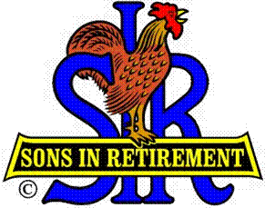
Las Trampas Branch 116
Luncheon Meeting Agenda
July 15, 2019, 11:30 AM

09:30 BEC Meeting
10:30 Social Hour
Greeters – Hank Haugse & Chris Doan
Raffle – Bob Huck, Ben Bryce
New Member Orientation – Mike Schneider
11:25 Five Minute Call
11:30 Call to order; Opening Remarks – Big SIR
Pledge of Allegiance – Darrell McClaughry
Chaplain – Dick Chaffee
Sunshine Report – Matt Arena
11:38 Story Teller – Mac McLoughlin
11:42 Introduce Speaker – Tony Elkrington
Guests – Recruitment -
New Member Induction – Jerry
Recognize Greeters – Jerry (Hank Haugse & Chris Doan)
Awards – Certificate of Appreciation
11:45 Salad Served
11:50 Announce election of Officers and Directors at August luncheon
11:52 RAMP Department Heads Reports
11:57 Activity Reports (if time)
12:00 Lunch
12:35 Activity Committee Reports
12:40 Speaker – Tony Elkrington
13:20 Speaker Thank You
13:22 Raffle Drawing – Ben Bryce
Birthday Drawing – Little SIR Michael Barrington
13:27 Sing Happy Birthday – Music –Robbie and Paul
Sing God Bless America
13:29 Closing Remarks – Big SIR
13:30 Adjourn; Next Meeting, August 19, Election of Officers and Directors

